1. Select Your Operating System (OS):

Choose an operating system that best suits your preferences and project requirements. Download and Install Windows 11. <https://www.microsoft.com/software-download/windows11>

1.) Go to the Microsoft official website to [download the Installation Assistant](https://www.microsoft.com/en-us/software-download/windows11) tool. Click **[Download now]** to start to download the **Windows 11 Installation Assistant** tool.

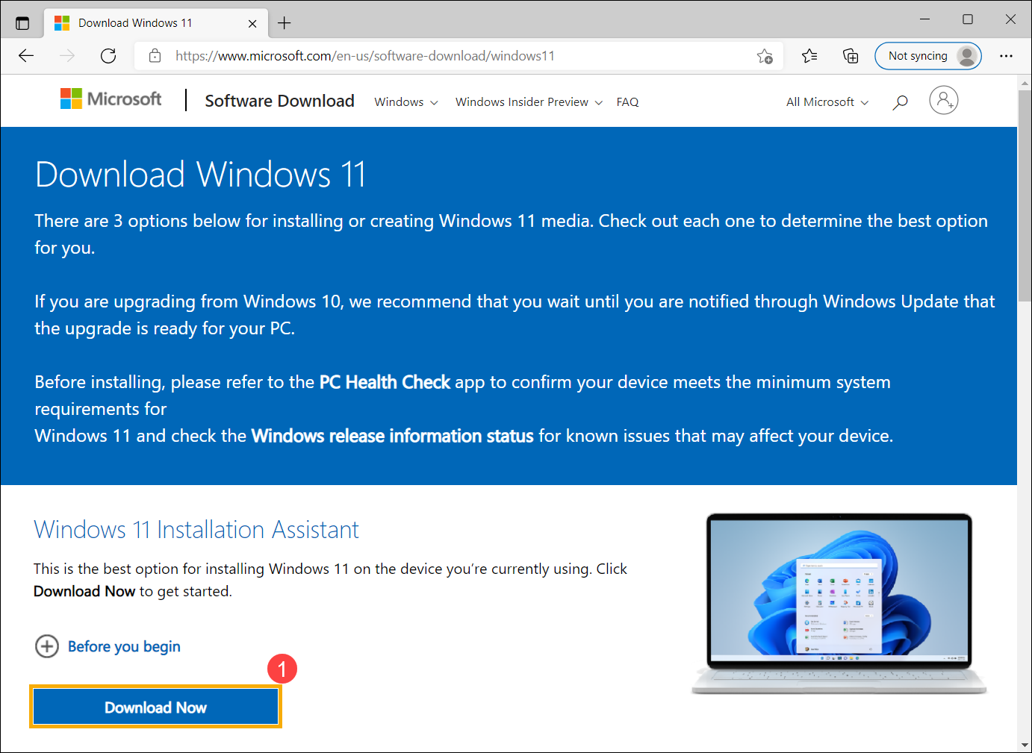

2.) After the download process is completed, double-click your downloaded tool

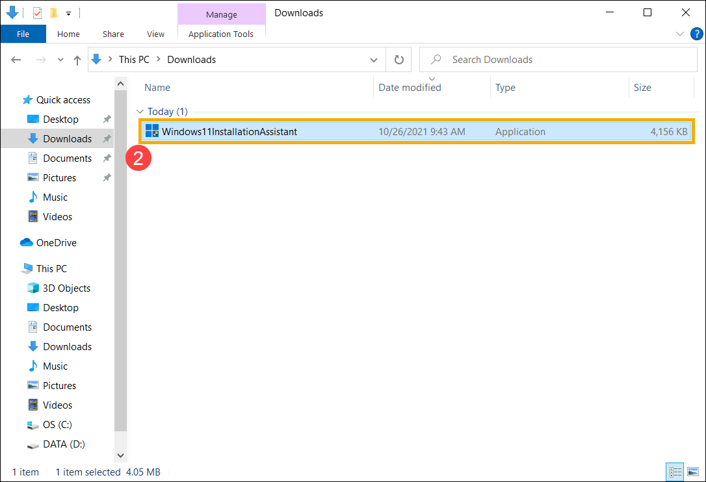

3.) If the User Account Control notification is appeared, please select **[Yes]**

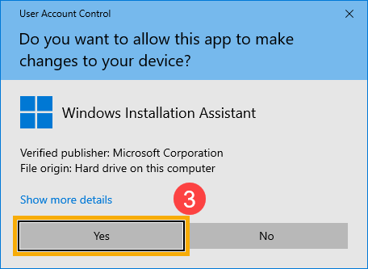

4.) Please read through the Microsoft software license terms, then select **[Accept and install]** to continue the Windows 11 upgrade process

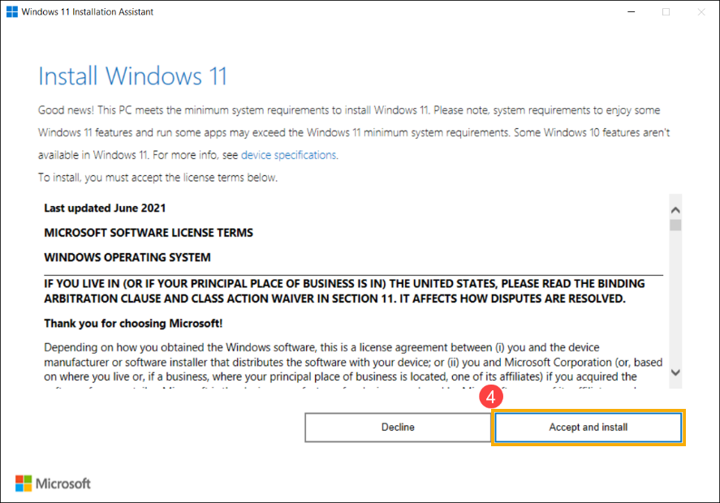

5.) Installation Assistant is downloading Windows 11. It may take some time to download, and it’s fine to keep using your PC.

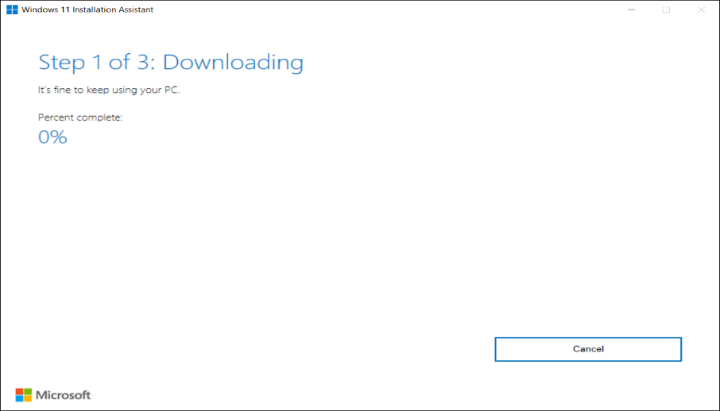

6.) After the downloading process is completed, please click **[Restart now]** to start to install Windows 11.  
Note: It will take some time to update Windows, so please make sure that the AC adapter is connected during the updating process. Also, please do not force to shut down to prevent any issue.

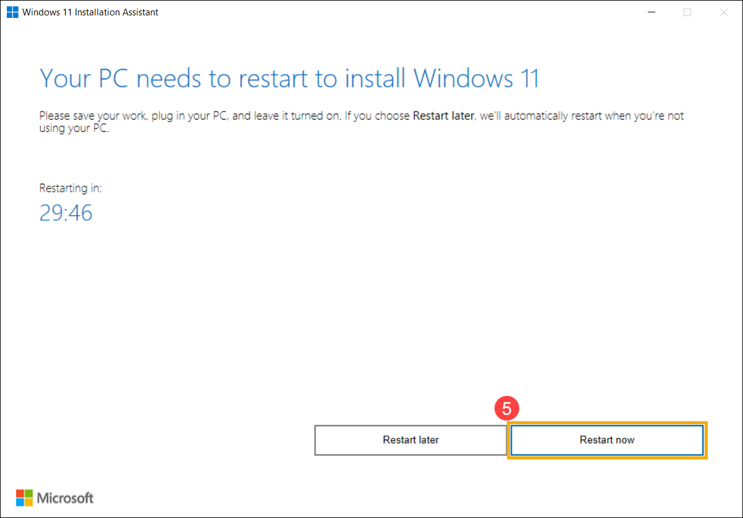

7.) After the computer enters the desktop again, it means Windows 11 installation is completed

2. Install a Text Editor or Integrated Development Environment (IDE):

Select and install a text editor or IDE suitable for your programming languages and workflow. Download and Install Visual Studio Code. https://code.visualstudio.com/Download

**Step 1:** Visit the [**Official Website**](https://code.visualstudio.com/docs/?dv=win) of the **Visual Studio Code** using any web browser like [Google Chrome](https://www.geeksforgeeks.org/how-to-browse-in-google-chrome-browser/), [Microsoft Edge](https://www.geeksforgeeks.org/tools-and-features-in-microsoft-edge-browser/), etc.

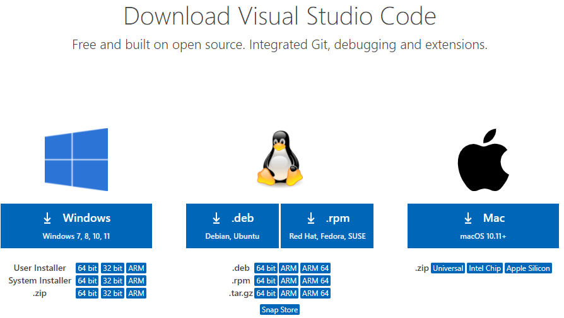

**Step 2:** Press the “**Download for Windows**” button on the website to start the download of the Visual Studio Code Application.



**Step 3:** When the download finishes, then the **Visual Studio Code Icon** appears in the downloads folder.

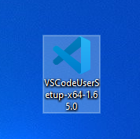

**Step 4:** Click on the **Installer** icon to start the installation process of the Visual Studio Code.

**Step 5:** After the Installer opens, it will ask you to accept the terms and conditions of the Visual Studio Code. Click on **I accept the agreement**and then clickthe **Next**button.

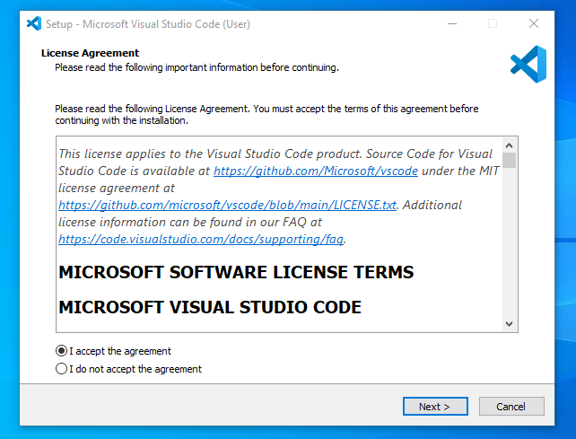

**Step 6:** Choose the location data for running the Visual Studio Code. It will then ask you to browse the location. Then click on the **Next** button.

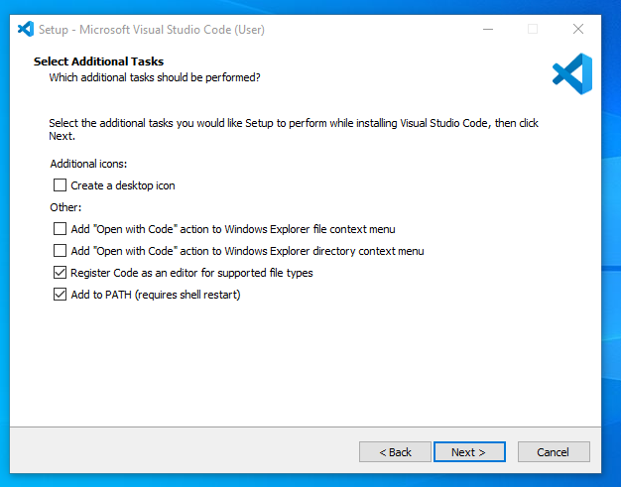

**Step 7:** Then it will ask to begin the installation setup. Click on the**Install** button.

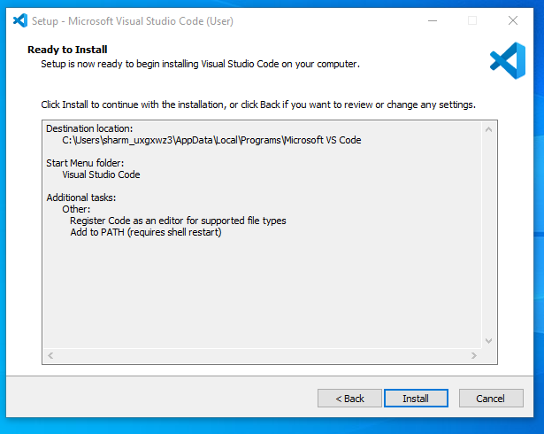

**Step 8:** After clicking on Install, it will take about 1 minute to install the Visual Studio Code on your device.

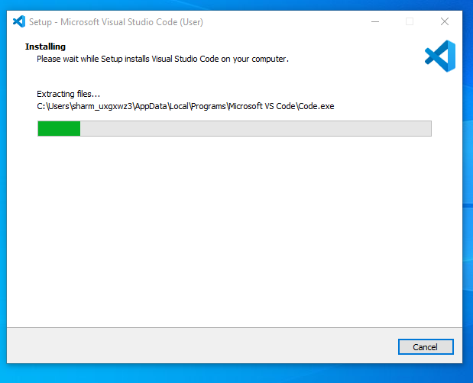

**Step 9:**After the Installation setup for Visual Studio Code is finished, it will show a window like this below. Tick the “**Launch Visual Studio Code**” checkbox and then click **Next**.

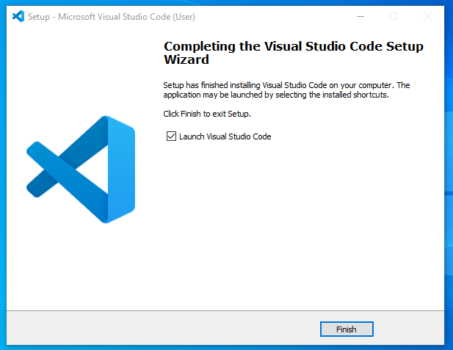

**Step 10:** After the previous step, the **Visual Studio Code window** opens successfully. Now you can create a new file in the Visual Studio Code window and choose a language of yours to begin your programming journey!

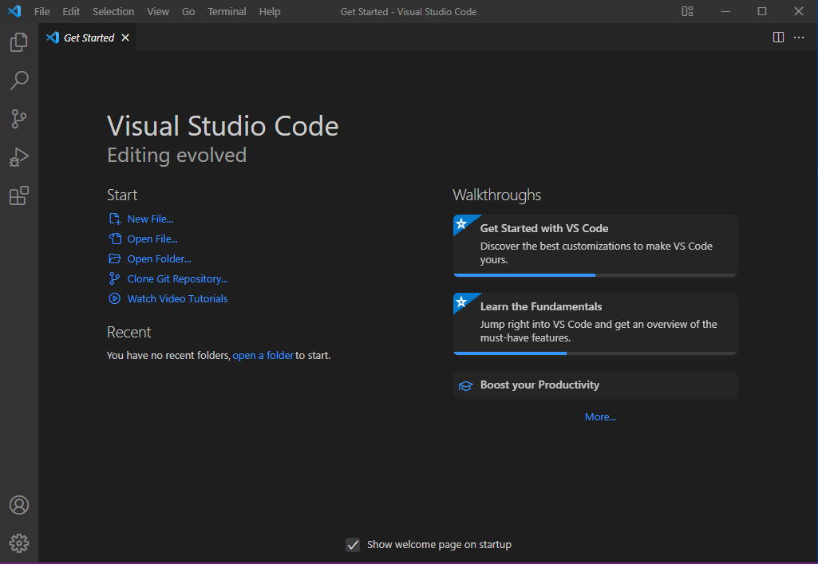

3. Set Up Version Control System:

Install Git and configure it on your local machine. Create a GitHub account for hosting your repositories. Initialize a Git repository for your project and make your first commit. https://github.com

1. Navigate to the [official Git downloads page](https://git-scm.com/download/win) and click the download link for the latest Git version for Windows:

The link contains the latest [64-bit](https://phoenixnap.com/glossary/what-is-x64) Git version for Windows. Alternatively, if you use a [32-bit](https://phoenixnap.com/glossary/what-is-x86) system, download the 32-bit Git installer.

2. Double-click the downloaded [file](https://phoenixnap.com/glossary/what-is-a-file) to extract and launch the installer.

3. Review the [GNU General Public License](https://phoenixnap.com/glossary/gnu-general-public-license), and when you are ready to install, click **Next**.

4. The installer prompts you for an installation location. Leave the default one unless you want to change it, and click **Next**.

5. In the component selection screen, leave the defaults unless you need to change them and click **Next**.

6. The installer offers to create a start menu [folder](https://phoenixnap.com/glossary/what-is-a-folder). Click **Next** to accept and proceed to the next step.

7. Select a text editor you want to use with Git. Use the drop-down menu to select Notepad++ (or whichever text editor you prefer) and click **Next**.

If you prefer to use a CLI text editor in [Git Bash](https://phoenixnap.com/kb/what-is-git-bash), select [nano](https://phoenixnap.com/kb/use-nano-text-editor-commands-linux) or [Vim](https://phoenixnap.com/kb/vim-commands-cheat-sheet) from the list.

8. The next step allows you to choose a different name for your initial branch. The default is **master**. Unless you are working in a team that requires a different name, leave the default option and click **Next.**

9. The next step allows you to change the **PATH environment**. The **PATH**is the default set of [directories](https://phoenixnap.com/glossary/what-is-a-directory) included when you run a command from the command line. Keep the middle (recommended) selection and click **Next**.

10. The installer prompts you to select the SSH client for Git to use. Git already comes with its own SSH client, so if you don't need a specific one, leave the default option and click **Next.**

11. The next option relates to server certificates. The default option is recommended for most users. If you work in an Active Directory environment, you may need to switch to Windows Store certificates. Select your preferred option and click **Next**.

12. The following selection configures line-ending conversion, which relates to the way data is formatted. The default selection is recommended for Windows. Click **Next** to proceed.

13. Choose the [terminal emulator](https://phoenixnap.com/glossary/terminal-emulation) you want to use. The default MinTTY is recommended for its features. Click **Next** to continue.

14. The next step allows you to choose what the **git pull** command will do. The default option is recommended unless you specifically need to change its behavior. Click **Next**to continue with the installation.

15. The next step is to choose which credential helper to use. Git uses credential helpers to fetch or save credentials. The default option is the most stable one. Select your preferred credential manager and click **Next**

16. The next step lets you decide which extra options to enable. If you use [symbolic links](https://phoenixnap.com/kb/symbolic-link-linux), which represent shortcuts for the command line, tick the box. Keep [file system](https://phoenixnap.com/glossary/filesystem) caching checked and click **Next**.

17. Depending on which Git version you are installing, it may offer to install experimental features. At the time this article was written, the installer offered options to include support for pseudo controls and a built-in file system monitor. For the most stable operation, do not install experimental features and click **Install**.

18. Once the installation is complete, tick the boxes to view the Release Notes or launch Git Bash if you want to start using Git right away, and click **Finish**.

8. Explore Extensions and Plugins:

   Explore available extensions, plugins, and add-ons for your chosen text editor or IDE to enhance functionality, such as syntax highlighting, linting, code formatting, and version control integration.

**Settings Sync:** Keeps your VS Code settings (like fonts, keyboard shortcuts) the same across all your devices. So, your coding environment feels familiar no matter where you code.

**Live Server:** Lets you see your code changes reflected in a web browser instantly, as you save them. Great for developing web pages without manually refreshing the browser all the time.

**Remote - SSH:** Enables you to work on code stored on a remote computer directly from VS Code on your local machine. Useful for connecting to servers or cloud environments for development.

**Prettier:** An opinionated code formatter that automatically arranges your code in a consistent style. Saves you time formatting and ensures clean, readable code.

**GitHub Copilot:** An AI-powered coding assistant that suggests code completions and even entire lines of code as you type. Like having a smart teammate helping you write code faster.

**Auto Rename Tag:** Makes life easier when working with HTML, XML, or JavaScript. When you rename an opening tag, it automatically renames the closing tag as well, saving you time and typos.

**GitLens:** Supercharges your Git experience within VS Code. It visualizes the history of your code, lets you see who made changes, and why. Makes working with version control more intuitive.

**Git History:** Another extension for Git users. It provides a clear view of your code's history, making it easier to navigate changes and revert to previous versions if needed.

**CSS Peek:** When working with HTML, this extension lets you hover over a CSS class and see the styles applied to it instantly, without switching between files.

**JavaScript Code Snippets:** Provides pre-written snippets of commonly used JavaScript code that you can insert into your code with a shortcut. Saves you time typing repetitive code blocks.

**Peacock (or other themes):** Lets you change the look and feel of VS Code's interface. Choose a theme that suits your style and helps you focus on coding.

**Colorize:** Adds color to your code based on syntax (keywords, functions, variables). Makes your code easier to read and understand by visually differentiating different parts.

**indent-rainbow:** Applies a rainbow of colors to your code indentation levels. This can be a fun way to visualize the structure of your code, especially for beginners.

**Code Spell Checker:** Acts like a spell checker for your code, identifying misspelled variable or function names. Helps you maintain clean and error-free code.

**Debugger for Chrome:** Allows you to debug your JavaScript code running in a Chrome browser directly from VS Code. Set breakpoints, step through code execution, and inspect variables to find and fix bugs.

**Icon Fonts:** Provides access to icon libraries within VS Code. You can easily insert icons from these libraries into your web projects.

**Turbo Console Log:** Enhances your console logging experience. It displays console logs with more formatting and color, making them easier to read and understand.

**TODO Highlight:** Helps you stay organized by highlighting keywords like "TODO" or "FIXME" within your code. This makes it easy to identify tasks and areas that need attention.

**vscode-icons:** Customizes the file and folder icons in VS Code. You can choose from various icon sets to personalize your coding environment.

**Regex Previewer:** Helps you test and visualize regular expressions (patterns used for text searching) right within VS Code. This is useful for web developers and data scientists who work with regular expressions often.

**Bookmarks:** Lets you set bookmarks within your code files. You can quickly jump back and forth between bookmarked locations, saving time navigating large codebases.